**PROJECT REPORT**

**INTRODUCTION**

**PROJECT OVERVIEW**

**DESCRIPTION:**

**This project is about HR analytics. Through this document, we will try to understand why our best and most experienced employees are leaving the company prematurely. Our challenge consists in guessing the reasons behind their leaving and to predict which valuable employees will leave next.**

**CONTENTS:**

* **Creation of IBM account**
* **Log into IBM cognos account**
* **Understanding the dataset**
* **Preparing the visualizations**
* **Dashboard creation**
* **Export the analytics**

**PURPOSE**

**HR analytics help HR teams set goals, measure success, and optimize processes so the company can focus on driving revenue. The interactive dashboards leverage on HR analytics platform which makes it easy to combine data from all systems and to deeply explore this data directly within the dashboard . When used responsibly and effectively, HR teams can quickly find insights that will improve recruiting , optimize workplace management and enhance employees performance.**

**LITRETURE SURVEY**

**EXISTING PROBLEM:**

* **A company conducted a employee engagement survey using a questionnaire developed by internal HR team. Then the responses collected from many employees. As to improve recruitment process in the company we analyse the given data.**
* **There are several existing methods/tools to solve this problem. One of the most used solution is R tool.**

**R:**

**R is the most used HR analytics tool. R is great for statistical analysis and visualization and is well-suited to explore massive data sets. It enables you to analyze and clean data sets with millions of rows of data. It also lets you visualize your data and analysis.**

**PROPOSED SOLUTION:**

**IBM COGNOS ANALYTICS:**

**IBM Cognos Business Intelligence is a web-based integrated business intelligence suite by IBM. It provides a toolset for reporting, analytics, score carding, and monitoring of events and metrics. The software consists of several components designed to meet the different information requirements in a company.**

**THEORITICAL ANALYSIS**

**BLOCK DIAGRAM:**

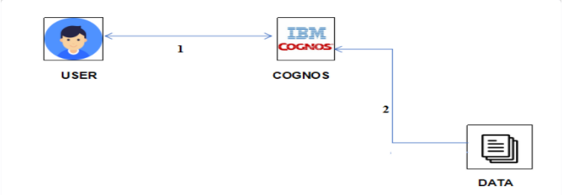

**HARDWARE/SOFTWARE DESIGNING VISUALIZATION**

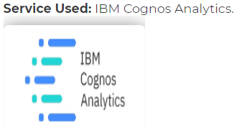

**ANALYSING OR INVESTIGATION**

**Once the data is collected choose the best visual representation to get the most information out of this data.**

**As a rule of thumb use,**

* **line graphs to track on evolving trend**
* **bar charts to compare different levels or repartition**

**The analysis of our project as following**

* **pay for performance**
* **skill set analysis**
* **predict movement**
* **fortify the workspace**
* **build work culture**

**FLOWCHART**

**Create an IBM Cloud account**

**Log into Cognos Analytics**

**Understanding the Dataset**

**Loading the Dataset**

**Prepare data visualization charts**

**Dashboard creation**

**Export the analytics**

**RESULT:**

**->Final findings (Output) of the project along with the screenshots.**

* **After creation of various data visualizations , all the visualizations are placed in the dashboard.**
* **Screenshots of the visualizations which are placed in the dashboard.**

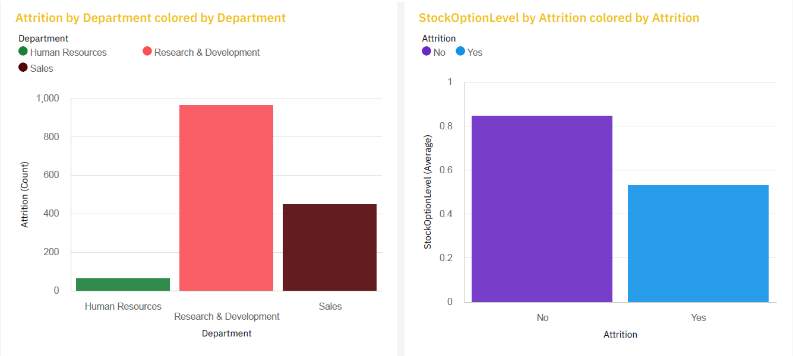

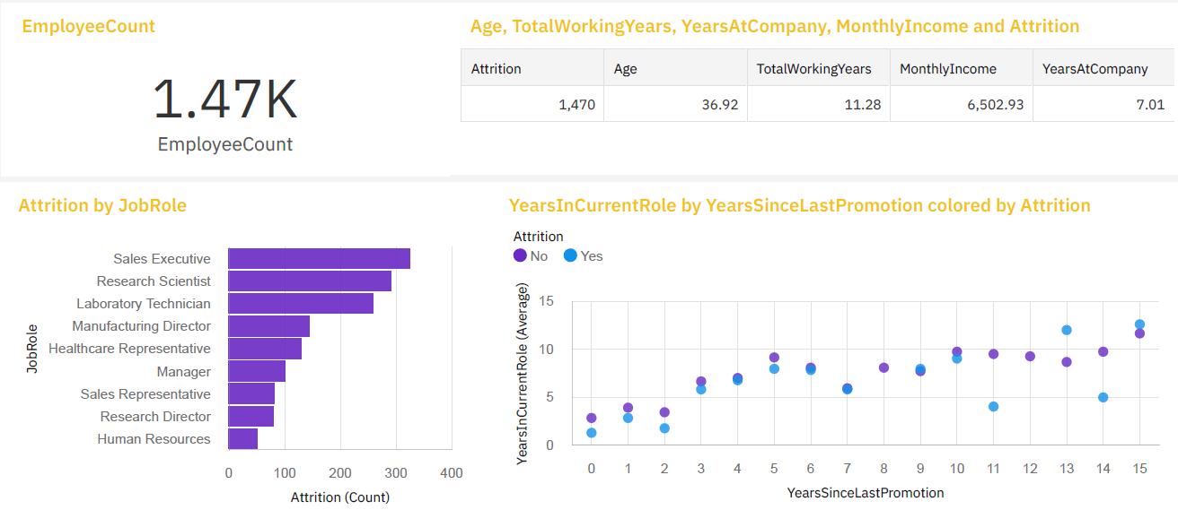

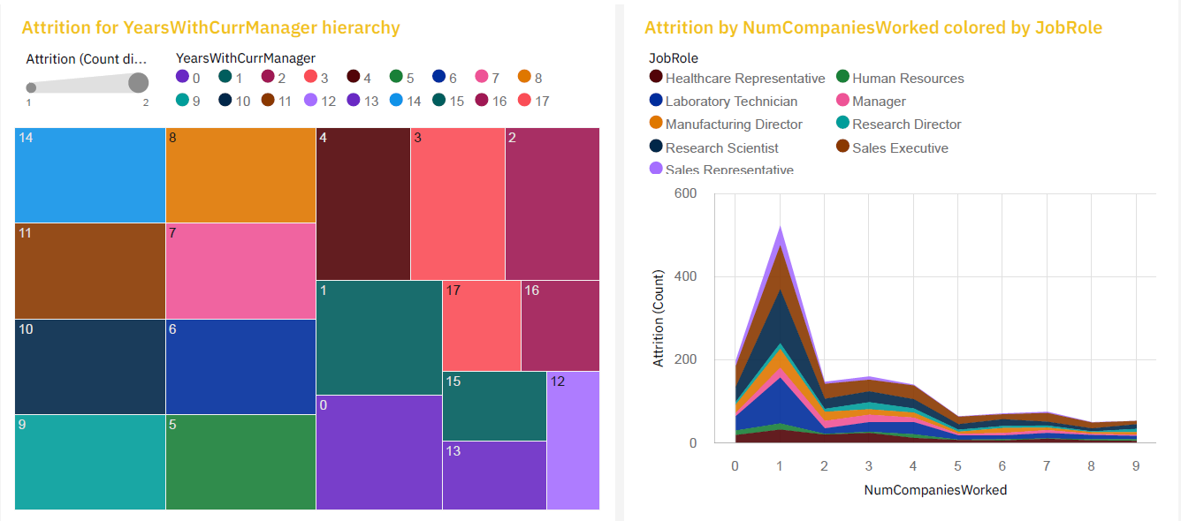

**ADVANTAGES AND DISADVANTAGES**

**->List of advantages and disadvantages of proposed solution.**

**ADVANTAGES:**

* **Improve retention**
* **Drive employee performance**
* **Create better compensation and incentive programs**
* **Supercharge recruitment**
* **Make real change to company culture**
* **Improve employee engagement**
* **Enable better workforce planning**
* **Promote better employee development**
* **It underpins machine learning**
* **Reduce attrition**
* **Improve experience**
* **Gain trust**
* **Improve processes**

**DISADVANTAGES:**

* **There are also a couple of disadvantages to using it in the current scenario.**
* **Since HRs deal with huge amount of sensitive and confidential data, security and privacy are two main concerns.**
* **Any HR analytics system which handles this data must be designed to prevent any unauthorized access.**
* **There have to be multiple levels of access and the system must be constantly monitored for any data theft.**
* **Maintaining such a system will obviously lead to greater costs and that’s the second main disadvantage to implementing HR analytics.**

**APPLICATIONS OF HR ANALYTICS:**

**->The areas where the solution can be applied.**

* **Employee surveys.**
* **Telemetric Data.**
* **Attendance records.**
* **Multi-rater reviews.**
* **Salary and promotion history.**
* **Employee work history.**
* **Demographic data.**
* **Personality/temperament data.**

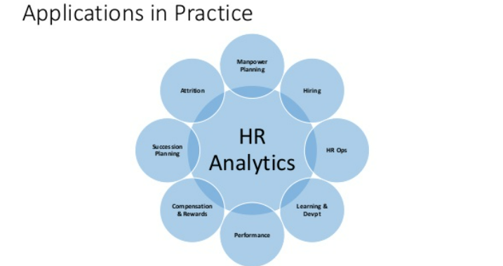

**CONCLUSION:**

**->Conclusion summarizing the entire work and findings.**

* **HR analytics is an essential part of data management and its implementation can yield positive returns for any organization. But as the above has shown, the management, analysis and interpretation of data isn’t always straightforward and organizations need to approach HR analytics one step at a time.**
* **The key to successful HR analytics relies on the understanding that the size of the measured data isn’t the key to success, but rather, the impact the data can have on decision-making in the organization. HR analytics shouldn’t be seen as influential only in the HR department, but rather as something, that has the potential to create value throughout the organization.**

**FUTURE SCOPE:**

**->Enhancements that can be made in the future.**

* **As high as 92% talent professionals in India consider People Analytics to pave the way for the future of HR and recruiting, according to a LinkedIn report. The 10th annual edition of the LinkedIn Global Talent Trends 2020 report shows that 95% of talent professionals in the country believe employee experience will shape the future of HR in the coming years.**
* **Today’s HR department is a product of the Industrial Revolution era. Back then, factories needed supervisors to ensure that workers produced reliable, standardized results day in and day out.**
* **In the digital age, technology has (mostly) taken over the responsibility of producing standardized results. HR departments of today have a responsibility to plan for a future of technology and humans working together to accomplish business goals. This means thinking about how to best develop your workforce with both the capabilities of your tech and employees in mind.**

**BIBILOGRAPHY**

**->References of previous works or websites visited/books referred for analysis about the project , solution previous findings etc.**

* [**https://smartinternz.com/Student/guided_project_info/2494#**](https://smartinternz.com/Student/guided_project_info/2494)
* [**https://www.questionpro.com/blog/hr-analytics-and-trends/**](https://www.questionpro.com/blog/hr-analytics-and-trends/)

**APPENDIX:**

**->Source code**

**Attach the code for the solution built.**

